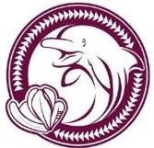

FAMILY MOVIE NIGHT

COME JOIN US FOR A NIGHT OF RELAXATION, FUN, AND FAMILY TIME!!!
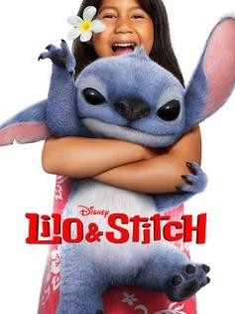
FRIDAY, NOVEMBER 14, 2025 5:00PM AT KAʻEWAI’S CAFETERIA

SELLING SNACK PACK $5
Costco Hotdog Popcorn Capri Sun
(Cash Only Please)
You may bring your own blanket, chair, or mat to sit on the ground. You may also bring in your own food, but please remember to throw away your own trash in the trash can.
If you will be joining us, please fill out this form (with payment, if any) and return to Ms. Anyas, Kaʻewai’s PCNC
Student Name: Grade: Rm #:
How many will attend:
How many snack packs: Total Payment (if any): $ Parent’s/Guardian’s Name: Parent’s/Guardian’s Contact Number:

Parent’s/Guardian’s Signature:

